**Infinitely monitor the folder and Process the customer and product Information**

**Document History**

|  |  |  |  |  |  |
| --- | --- | --- | --- | --- | --- |
| **Version** | **Release Date** | **Created By** | **Description of**  **Change** | **Genpact**  **Approval by** | **Customer**  **Approval by** |
| 1.0 |  |  |  |  |  |
|  |  |  |  |  |  |

**Terminology & Abbreviations used**

|  |  |
| --- | --- |
| Process Folder | Customer product files will be placed inside this folder |
| Achieve Folder | After analyzed the process file, file will be moved to achieve |
| Config file | It contains all the required details of the customer and other input details |
| Flow Chart | Keep all the product count list and product names |
| Customer details | The details of the products retrieved from product file and config file |
| Product counts | The number of files product has been placed inside the Process folder for  product |
| Log file & Snapshot | If any errors while bot execution, the global handling exception will catch the error and screenshot |
|  |  |

**TABLE OF CONTENT**

1 Introduction 4

2 Overview 4

2.1 High Level Manual Process Description 4

2.2 Target Applications 5

2.3 Process Prerequisites 5

2.4 Definitions 5

3 Process Diagram - 6

4 Monitor the folder and process the customer and product information Description 7

5 Scheduling of Activities 10

6 User rights and access 10

# Introduction

This document provides a detailed and step by step understanding of “Customer and Product management of the products”. Need to handle the product files based on the company and its products. If files placed inside the Process folder, we need to analyse and get the product details and move the files into the Achieve folder. Once we get the file name, product name, customer name and product count, will store the same into excel sheet. When the number of product count reaches ten each time, will plot the flow chart and the chart to appropriate customer.

# Overview

## High Level Manual Process Description

1. Read the config file config.xls, in that Sheet1 is config information of customers and Sheet2 folder path to watch
2. Create a trigger that if any files places under the Companies folder and trigger should be trigger only if a file is placed under the process folder, not archive folder. Path to watch will have all companies separate folder
3. Keep an infinite running bot, once it has started, it will be running nonstop.
4. Once the file is placed inside the process folder the bot will be process the file like reading the customer name, file name and product name.
5. Create a excel sheet and store all those retrieved data into it.
6. Also, it will keep adding those records in excel file at customer level folder
7. Delete and Move the file from process to Archive folder, after we get the all the details from product file.
8. Send the Passed or Failed email to the appropriate recipients given in the config file.
9. Another task is, when there is any new update comes, it will take all records for that company and group the data by product and create a excel file
10. If there are more than 10 entries for that company. Plot the data in graph in excel, save excel
11. Send the excel to fixed email recipient along with the flow chart.
12. Keep the Global handling exceptions to capture the errors and send error emails if occurred.

## Target Applications

The following applications / systems are necessary to have access to, in order to perform Infinitely monitor the folder and Process the customer and product Information:

1. Microsoft Outlook
2. Microsoft Excel
3. File/Folder Access
4. Bot Trigger

## Process Prerequisites

1. Config file
2. Access to Companies files/folders
3. Access to Microsoft applications – Excel and Outlook

## Definitions

1. **Trigger**

The ‘trigger’ is used to initiate the bot runner based on how we define and constructs the trigger.

1. **Process Folder**

The product files will be placed

1. **Archive Folder**
2. **Flow Chart**

# Process Diagram -

Below is the high-level process flow showing step by step.

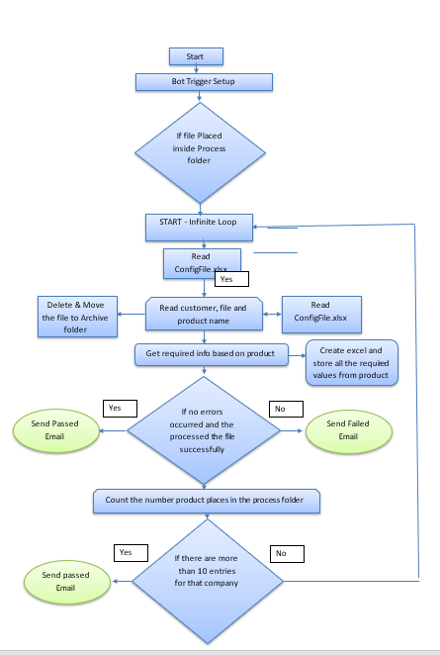

# Monitor the folder and process the customer and product information Description

Steps required to be followed for file/folder process and product management:

1. Read the config file config.xls, which contains all the required input details
   * In Sheet1 is config information of customers
   * In Sheet2 folder path to watch
2. Create a trigger that if any files places under the Companies folder and trigger should be trigger only if a file is placed under the process folder, not archive folder.

Path to be watched the below format:

* + Path to watch will have all companies separate folder

Fig : 2.1 – Companies folder format

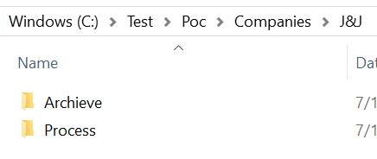

Fig : 2.2 – Trigger options

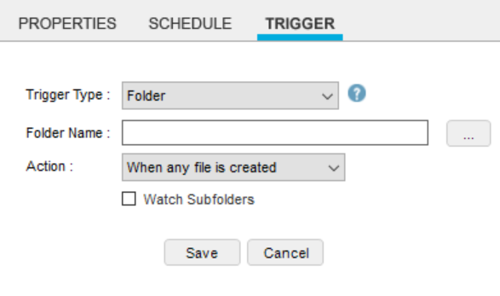

1. Keep an infinite running bot, once it has started, it will be running nonstop.
2. Once the file is placed inside the process folder the bot will be process the file like reading the customer name, file name and product name.

Fig 3.1 – Product file format

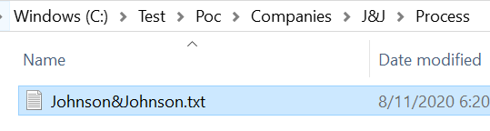

1. Create a excel sheet and store all those retrieved data into it.

Fig 4.1 – Sample Customer Details format

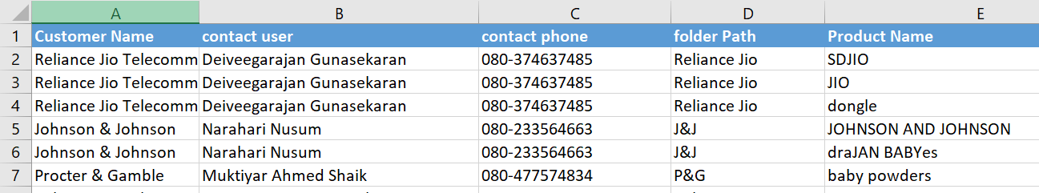

1. Also, it will keep adding those records in excel file at customer level folder

Fig 5.1 – Sample product Name and Count format

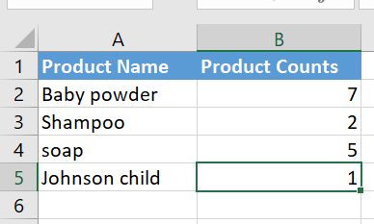

1. Once the files have been processed. Delete the file from process folder and Move the file to Archive folder, after we get the all the details from product file

Fig 7.1 – Sample Archive folder/file format

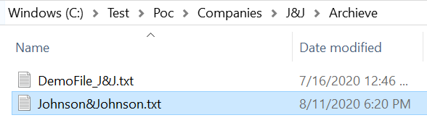

1. Send the Passed or Failed email to the appropriate recipients given in the config file.
2. Another task is, when there is any new update comes, it will take all records for that company and group the data by product and create a excel file. Refer Fig (4.1 and 5.1)
3. If there are more than 10 entries for that company. Plot the data in graph in excel, save excel

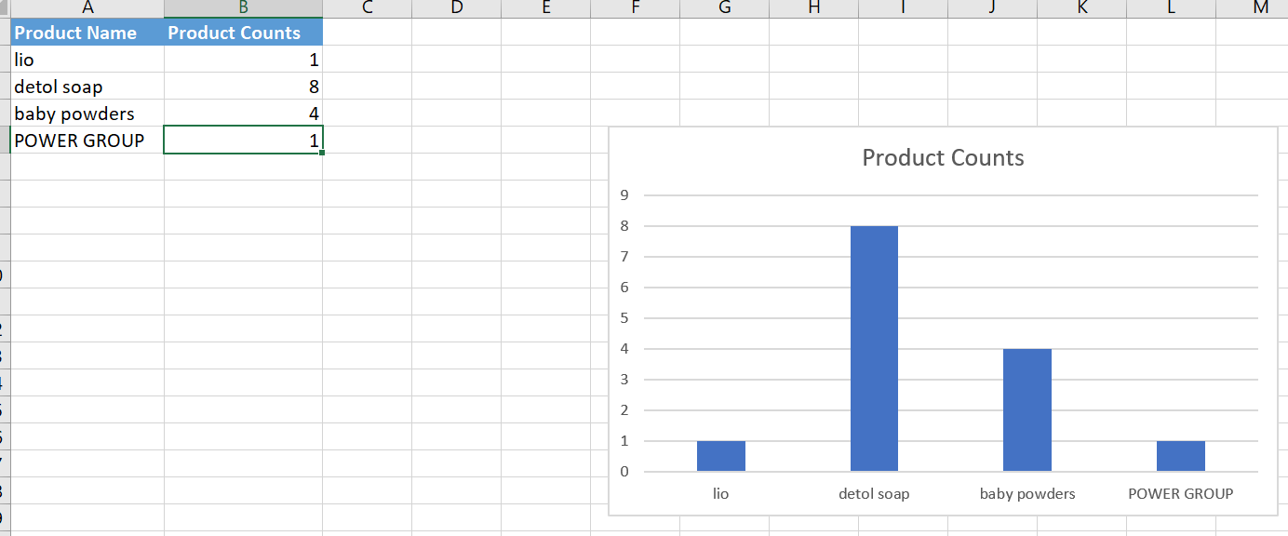

1. Send the excel to fixed email recipient along with the flow chart.
   * Below is the sample template for the successful emails

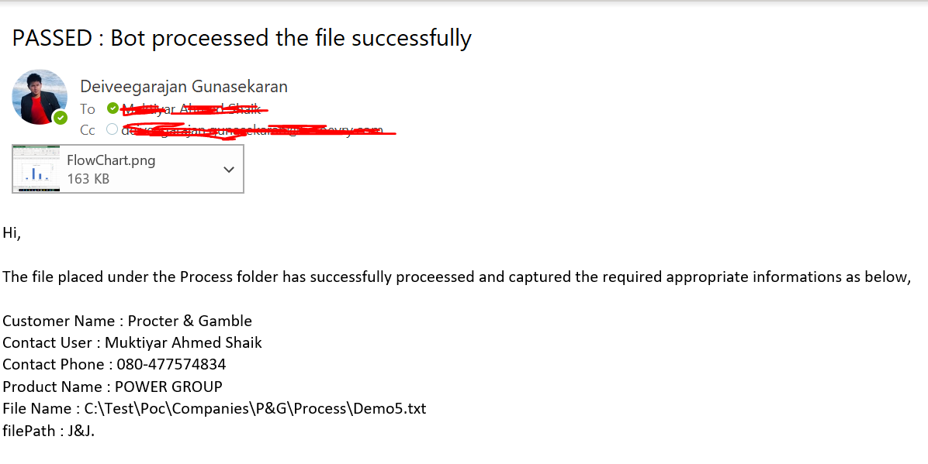

1. Keep the Global handling exceptions to capture the errors. If any errors throw while execution, send the emails to the administration team.
   * Snapshots
   * Log file

# Scheduling of Activities

The frequency of “Infinitely monitor the folder and Process the customer and product Information” is a continuous execution, whenever the files has placed inside the Process folder the bot will start monitoring and processing the folder and files infinitely.

# User rights and access

The user needs mainly the company’s files and folders access to perform the required actions.